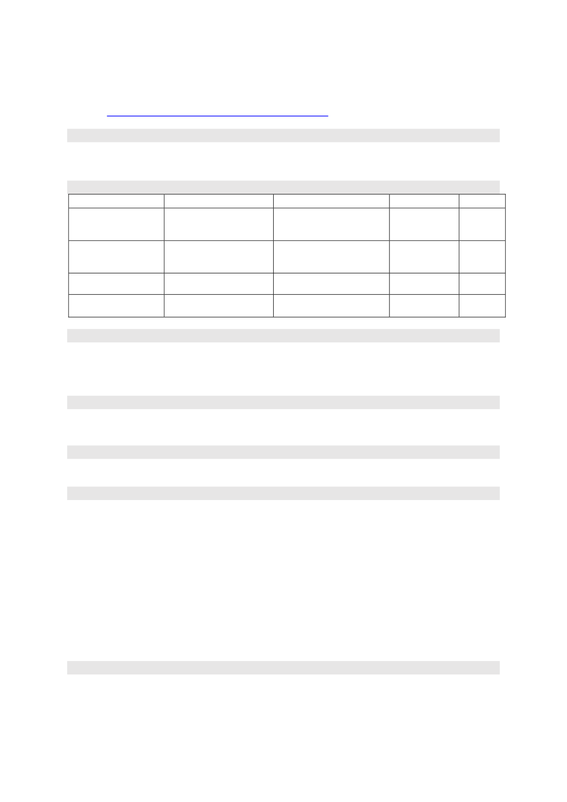
AKSHAY L
Email: akshaylatha133@gamil.com
Mobile:+91 9361008966
LinkedIn: https://www.linkedin.com/in/akshay-l-7831b429a
CAREER OBJECTIVE | FINANCE | OPERATIONS |CAPITAL MARKETS
Eager to kick-start my career in Finance and Operations with a reputable company that offers
opportunities for skill development and career advancement. I aim to leverage my management
skills to contribute positively to the organization's objectives and foster personal growth.
ACADEMIC PROFILE
DEGREE | INSTITUTION | UNIVERSITY/BOARD | YearofPassing | CGPA

MBA – Finance and | St. Joseph’s college of | AnnaUniversity | May 2025 | 7.5
Operations Engineering,
Chennai
B.com- Professional | Bishop Appaswamy | Bharathiar University | May 2023 | 7.5
Accounting College of Arts and
Science, Coimbatore
Senior secondary (12th) | Stanes Anglo Indian School, | Board of Higher Secondary | March 2020 | PASS
Coimbatore Examinations, Tamil Nadu
Secondary (10th) | Stanes Anglo Indian School, | Board of Secondary | March 2018 | PASS
Coimbatore Examinations, Tamil Nadu
TECHNICAL EXPERTISE
• Microsoft Office
• Power BI - Basic
• ProwessIQ
• PSPP
SKILLS
• Good verbal and written communication skills,
• Leadership & Public speaking.
• Photographing and Editing
CERTIFICATIONS
• Fundamentals of Capital Markets – Finmark
• Personality Enrichment Program – Copversity
PROFESSIONAL EXPERIENCE
AIRPORTS AUTHORITY OF INDIA – 30 DAYS
• Assisted in Airport Operations - Supported the management of day-to-day airport operations, ensuring compliance
with safety and efficiency standards.
• Data Analysis - Worked on analyzing data related to passenger traffic, flight schedules, or airport services for
performance optimization.
• Technical Support - Helped with maintenance and troubleshooting of airport systems, such as radar, air traffic control,
or communication systems.
ROOTS INDUSTRIES INDIA PRIVATE LIMITED – 3 MONTHS
• Produced high-volume horn and wiper sub-assemblies on a takt-time line that produced 120+ units/hour and <1%
rework.
• Established a labeling system in the dispatch bay to enhance loading preparation time, reducing them to roughly 20
minutes per shipment.
• Implemented in-process poka-yoke inspections aligned to ISO 9001 / IATF 16949 standards and had no complaints
during my internship position.
EXTRA CURRICULAR ACTIVITES
• State level Basketball Player.
Declaration: All the above information is correct to the best of my knowledge, and I am responsible
for its correctness.
Place : Chennai
Date | : June 2025 | Akshay L

